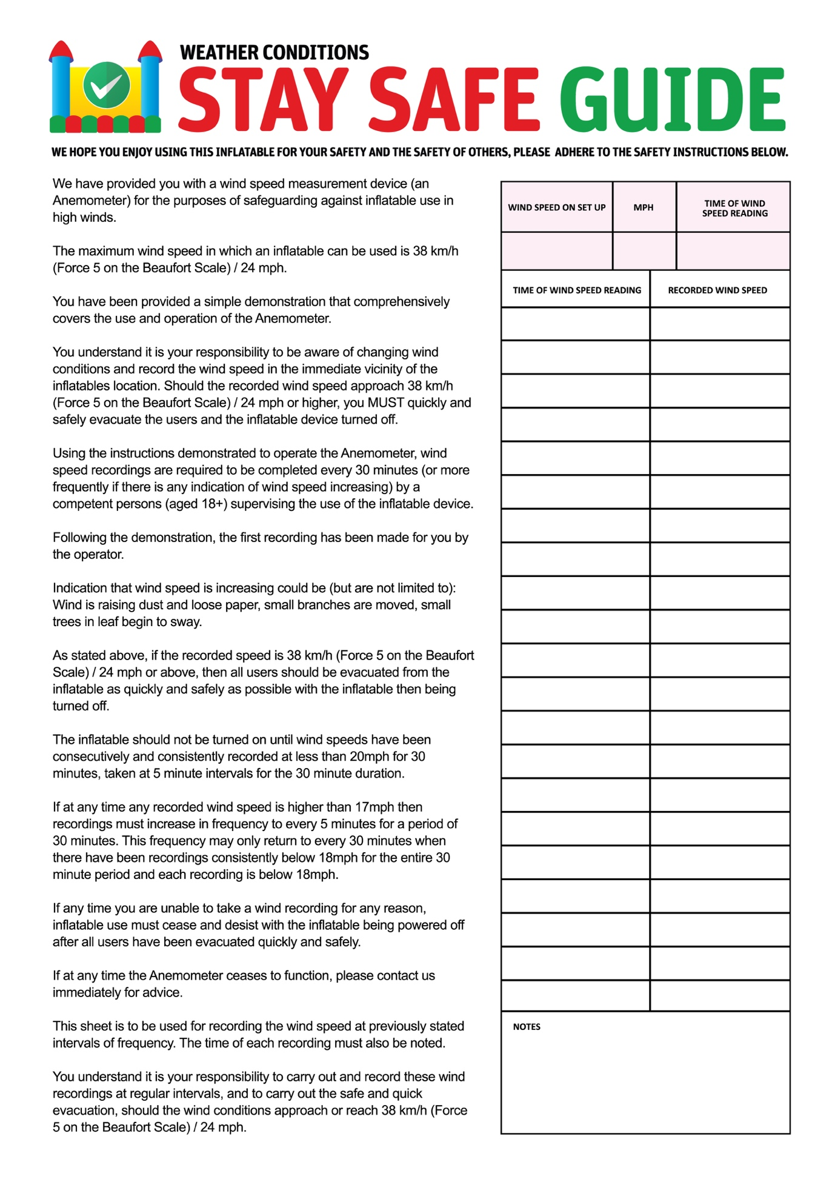

|  |  |  |
| --- | --- | --- |
| WIND SPEED ON SET UP | KMP | TIME OF WIND SPEED READING |
|  |  |  |

|  |  |
| --- | --- |
| TIME OF WIND SPEED READING | RECORDED WIND SPEED |
|  |  |
|  |  |
|  |  |
|  |  |
|  |  |
|  |  |
|  |  |
|  |  |
|  |  |
|  |  |
|  |  |
|  |  |
|  |  |
|  |  |
|  |  |
|  |  |
|  |  |
|  |  |
|  |  |
|  |  |
|  |  |
|  |  |
|  |  |
|  |  |
|  |  |
| Notes: | |
| Hirer Signature  ---------------------------------------  Employee Signature  ---------------------------------------- | |

We have provided you with a wind speed measurements device (an Anemometer) for the purpose of safeguarding against inflatable use in high winds. Initial Here

The maximum wind speed in which an inflatable can be used is 30 km/h (Force 4 on the Beaufort Scale). Initial Here

You have been provided a simple demonstration that comprehensively covers the use and operation of the Anemometer. Initial Here

You understand it is your responsibility to be aware of changing wind conditions and record the wind speed in the immediate vicinity of the inflatable/ride location. Should the recorded wind speed reach 30 km/h you MUST quickly and safely evacuate the users and turn off the inflatable/ride. Initial Here

Using the instructions demonstrated to operate the Anemometer, wind speed recordings are required to be completed every 30 minutes (or more frequently if there is any indication of wind speed increasing) by a competent persons (aged 18+) supervising the use of the inflatable device. Initial Here

Following the demonstration, the first recording has been made for you by BWE staff. Initial Here

Indication that wind speed is increasing could be (but not limited to): Wind is raising dust and loose paper, small branches are moved, small trees in leaf begin to sway and crested wavelets form on inland waters. Initial Here

The inflatable/ride should not be turned on until wind speeds have been consecutively and consistently recorded at less than 30 km/p for 30 minutes, taken at 5 minute intervals for the duration. Initial Here

If at any time any recorded wind speed is higher than 26 km/h then recordings must increase in frequency to every 5 minutes for a period of 30 minutes. This frequency may only return to every 30 minutes when there have been recordings consistently below 26 km/p for the entire 30 minute period and each recording is below 26 km/h.

Initial Here

If any time you are unable to take a wind recording for any reason, the inflatable/ride use must cease and desist with the inflatable being powered off after all users have been evacuated quickly and safely. Initial Here

If at any time the Anemometer ceases to function, please contact us immediately for advice. Initial Here

This sheet is to be used for recordings the wind speed at previously stated intervals of frequency. The time of each recording must also be noted. Initial Here

You understand it is your responsibility to carry out and record these wind recordings at regular intervals and to carry out the safe and quick evacuation, should the wind conditions approach or reach 30 km/h ( Force 4 on the Beaufort Scale). Initial Here

|  |  |  |  |  |  |
| --- | --- | --- | --- | --- | --- |
| 4 | Moderate winds | 20 - 29 km/h | 11-16 knots | Raises dust and loose paper; small branches are moved. | Small waves - becoming longer; fairly frequent white horses. |

**BEAUFORT WIND SCALE**

**When the above wind conditions occur please remove all patrons from the inflatable and deflate. Do not inflate until the wind subsides. To check the forecast for wind conditions we use**[**www.wind.willyweather.com.au**](http://www.wind.willyweather.com.au)**.**We take no responsibility if you do not adhere to the above requirements.